Stop Teaching, Start Inspiring

AIEA Conference 2023, Washington DC

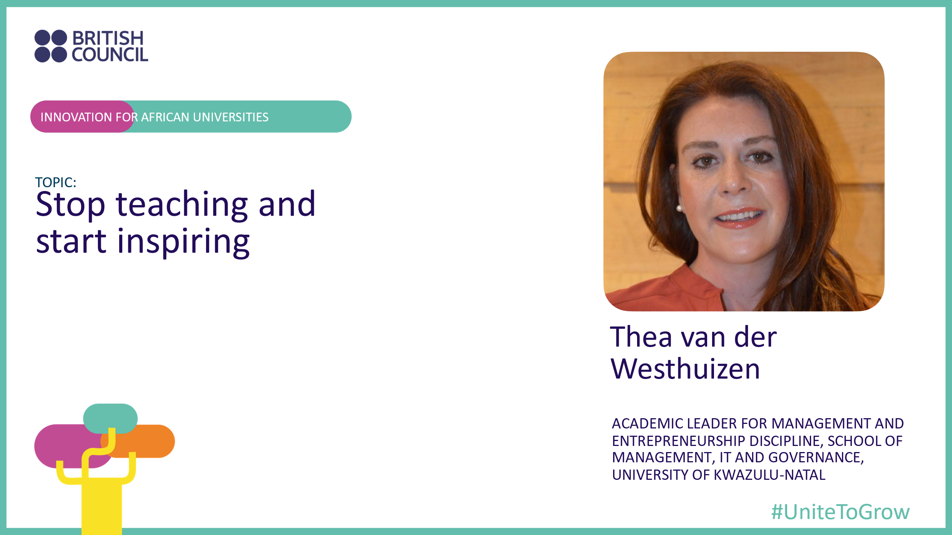

A seventeen-hour non-stop flight from Johannesburg to Washington’s Dulles International Airport can stretch to thirty-six hours across seven time zones. That’s a long way to bring a message. We weren’t even sure that the message would be listened to.

If “globalisation” is the process of bringing a business to the rest of the world, our aim was to bring a message of African Entrepreneurship Education to the world’s Higher Education elite gathered for four days in Washington for the 2023 Association of International Education Administrators Conference. The our case study: the Innovation for African Universities programme that is supported by the British Council and rolled out in South Africa, Kenia, Ghana, Nigeria and the United Kingdom, making it the largest entrepreneurial ecosystemic initiative ever in Sub-Saharan Africa.

## But we are Teachers…

Our small team, mostly from sub-Saharan Africa, hoped that bringing a message of “*stop teaching, start inspiring*” would stir things up a bit. After all, as academics in Higher Education our reason for being is about learning and teaching, and research, right?

Well, yes, but in recent times another – perhaps overriding – mission has been added: engagement with the community. This fundamentally changes the university’s purpose of enhancing academic knowledge to focus on its use-value. This purpose is never more appropriate than when applied to developing student entrepreneurs.

## British Council Support

For many years, the British Council has been at the forefront of recognising and supporting the critical importance of entrepreneurship education in HE institutions in Africa. Their presence at this conference was an indication of this support.

The presenting team was here to showcase British Council-supported initiatives in entrepreneurship development in Africa. Innovative and practical entrepreneurship programmes are being implemented at the Universities of KwaZulu Natal in Durban (*SHAPE* programme), Stellenbosch near Cape Town (*ClimateLab*), and the inclusive *Business Innovation and Incubation Centre* (BIIC) spanning five sub-Saharan Africa economic zones.

## The SHAPE Programme

Dr Thea van der Westhuizen is the Academic Leader for Management and Entrepreneurship at the University of KwaZulu Natal in Durban. Her research on applied entrepreneurship education models over the last decade has culminated in a published book entitled “Effective Youth Entrepreneurship”[1].

Dr Van der Westhuizen’s research draws on an intriguing combination of Otto Scharmer’s Theory U adapted to a Design Thinking approach. In this scenario, the student entrepreneur is encouraged to move from “reactive thought” to “generative thought” by a process of:

* **Inspiration** through co-initiation and co-sensing
* **Ideation** through co-sensing and co-inspiring, and
* **Implementation** through co-inspiring, co-creating and co-evolving

In this model, there are four stages culminating in Entrepreneurial Activity (EA).

1. **Entrepreneurial Self-efficacy** (ESE) initiates entrepreneurial activity, and is a combination of four “task specific” aspects:
   1. Opportunity identification
   2. Relationships
   3. Management
   4. Tolerance.
2. **Individual Entrepreneurial Orientation** (IEO) is nurtured as the aspiring entrepreneur develops an aptitude for:
   1. Risk-taking
   2. Innovation, and
   3. Proactivity.
3. **Entrepreneurial Intention** (EI), the third stage, is the flowering of self-efficacy (ESE) combined with individual orientation (IEO).
4. **Entrepreneurial Activity** is the natural result of the sum of (ESE + IEO + EI).

The theory is backed up by solid research, but the drawcard is Dr Van der Westhuizen’s translation of theory into practice. Hence her call to arms: *Stop teaching, start inspiring*!

## It’s about Relationships

The relationship with self, mindset and entrepreneurial heartset – the personality traits – described in her SHAPE Youth Entrepreneurship model is only the starting point for a comprehensive support network comprising educational institutions, government and private sector agencies, and communities.

Through these support networks, the entrepreneurial practitioner collaborates with the youth entrepreneur small/medium business ecosystem to share experiences and social skills, and form business friendships.

This S/M collaboration can be a springboard to collaboration with corporations and large businesses who may provide a platform for internships and on-the-job learning opportunities. Ultimately, internationalisation of the business may be an option to enhance employability, the quality of employment, or business creation through the expansion of network partners.

## Bridging the Gap

Mapped out in eleven discrete phases over fourteen months, the SHAPE programme has been running successfully at UKZN since 2015, providing the ideal mechanism to bridge the “valley of death” gap between academia and the world of work.

## Investment in African Start-ups

Despite a reported slowdown in global investment in start-ups[2], the African tech sector in particular remains “an enclave of growth”. Africa is the only region not to see this slowdown in investment, and in fact experienced increased investment in 2021 and 2022.

Given that 22% of the working-age population across Africa own their own businesses, investment in education and skills training – such as the SHAPE programme – can only reap increasing rewards.

1. Van der Westhuizen, T. Effective Youth Entrepreneurship. 2023, Sunbonani Scholar, South Africa. 447 pages
2. See [this article](https://subscriptions.touchbasepro.com/t/d-l-zdkhddl-tytizkydu-td/).